DATE: 23.08.2019
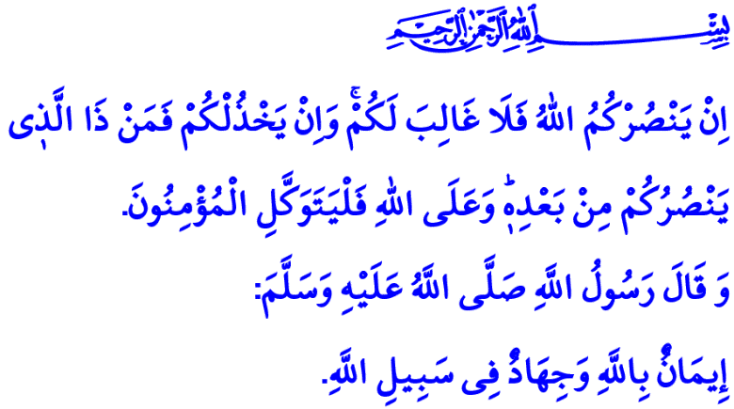
THIS HOMELAND IS OURS AND UNDER OUR PROTECTION
Honorable Muslims!
Allah the Almighty (swt) states in the verse I have recited, “If Allah should aid you, no one can overcome you; but if He should forsake you, who is there that can aid you after Him? Upon Allah let the believers rely.”
According to the hadith I have read, when asked, “What is a good deed?”, the Prophet Muhammad (saw) replied, “To believe in Allah, and fight for His cause.”
Dear Believers!
The land on which we live means much more than just a piece of land. We put forth our chest as a shield to defend the land, on which we live freely and to continue living freely, against all kinds of disgraceful attacks. It is the most beautiful land on earth for us, not an inch of which we will forsake for all worlds. It is the sacred legacy of our martyrs who sacrificed their lives, gave up on their beloved ones and all they had, were honored with the rank of martyrdom, and of our war veterans who devoted their existence for it.
Dear Muslims!
Defending the land for us does not mean only overseeing a piece of land. It means to make every effort to uphold all high values that make a piece of land “our homeland.” We defend the life, religion, property, future, dignity, and honor of every individual living on this land. We stand by the side of all oppressed and victimized people without making any discrimination of religion, language, or race, and we do not let down the hopes of those who rely on us. We fight for keeping up and waving in the sky our national flag that is the symbol of our independence and future existence. We proudly bear all kinds of sacrifices to let the adhans, the testimonials of which is the foundation of Islam, echo in the sky forever.
Dear Believers!
It is a sacred duty for all Muslims to love and defend their countries. It is a divine commandment to be prepared against the enemy for any kind of psychological, technological, or economic warfare. In this regard states the Almighty Allah (swt), “O you who have believed! Persevere, endure, remain stationed, and fear Allah that you may be successful.” Similarly, the Prophet Muhammad (saw) emphasizes this holy struggle for the truth and the right as follows, “Strive with your wealth, your hands, and your tongues.”

Dear Muslims!
August is an exceptionally important month for in the past our ancestors demonstrated matchless heroism in defence of our land and all that is sacred for us. Our glorious forefathers, with their hearts full of faith and with their courage and resoluteness, won unprecedented victories, leaving their marks in many Augusts. Their greatest witnesses are the victories won from the Battle of Malazgirt (Manzikert) through the Battle of Kosovo, and from the Battle of Mohacs through the Greco-Turkish War (the Turkish Great Offensive).
These victories show us that Allah’s help has always been with the believers. When the believers asked, ”When is the help of Allah?”, Allah the Exalted (swt) always supported them with the good news, 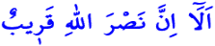”Unquestionably, the help of Allah is near.”
Honorable Believers!
No enemy hand will touch upon our land even if there is a single house is left standing. Upholding the unity and solidarity above any personal interest and working courageously and resolutely, our noble nation will never kneel down before any kind of derogation. Those who want to damage our brotherhood, our affection for each other, and our peace are doomed to lose today, too, just as in the past. Because those who stand by Allah and work in a fair and sincere manner will eventually be victorious. Those who stand by the falsehood, oppression, cowardice, and evil will definitely disappear one day. As expressed in the Holy Qur’an, “Truth has come, and falsehood has departed. Falsehood, indeed, is by nature ever bound to depart.”
Dear Muslims!
Sustaining its honorable journey from the past to the present, the existence of our noble nation is a hope for the world. We can stand against the oppressors and protect the oppressed only if we defend our land, nation, and sacred values altogether, and be powerful both materially and spiritually.
Then, let us, young or elderly, take our ancestors as the example, and embellish ourselves with the same faith, the same cause, the same resoluteness, the same loyalty, and the same submission to Allah. Let us not give a chance to those who want to suppress our country, disrupt our unity and solidarity, and cause turmoil and disorder in this beloved land of ours. Let us never move away from righteousness, benevolence, and the truth and the right.
As I conclude the khutbah, I would like to commemorate, wishing Allah’s mercy upon and with heartfelt gratitude for, our honorable martyrs and heroic veterans who have borne the banner of Islam throughout the history and bequathed this heavenly homeland for us.

Al-i ‘Imran, 3/160.
Bukhari, ‘Itq, 2.
Al-i ‘Imran, 3/200.
Nasa’i, Jihad, 48.
Baqarah, 2/214.
Isra, 17/81. General Directorate of Religious Services

